

“The Only Thing That Matters”

User Manual

Customer Portal



Contents

1. Login (Customer) 3

2. Home Page 6

3. Dashboard 7

4. Detailed Reports 17

5. Invoice 19

6. Payment 20

7. Contact Us 23

8. Mapping charges of an invoice 23

# Login (Customer)

* URL:

By keying in the above mentioned URL, you will land to the login page of “GREEN MATTERS” as shown below:

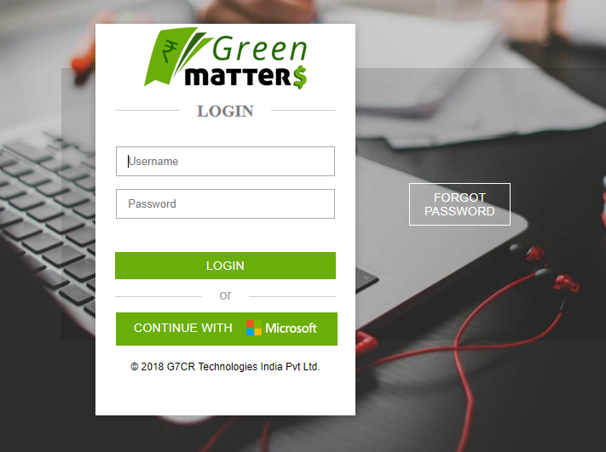

* Select the “CONTINUE WITH MISCROSOFT” button to proceed with logging.

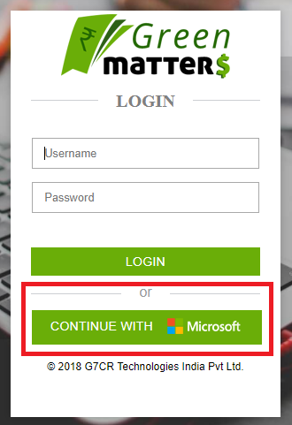

* You will be redirected to the “Microsoft” URL, please enter your login credentials from “Microsoft” as shown below steps.

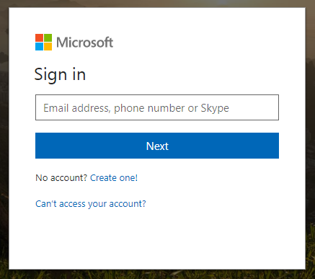

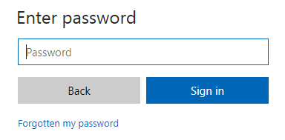

* If you are a logging in for the first time the below prompt will show up, select “Accept” and proceed

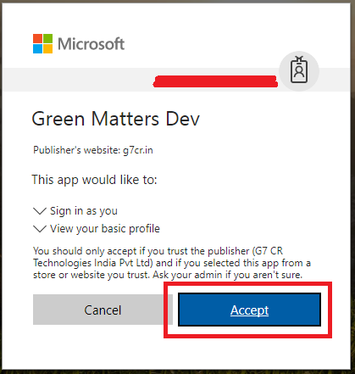

* As per the user’s requirements they can select either to save the credentials or key in the details every time they want to login as show below:

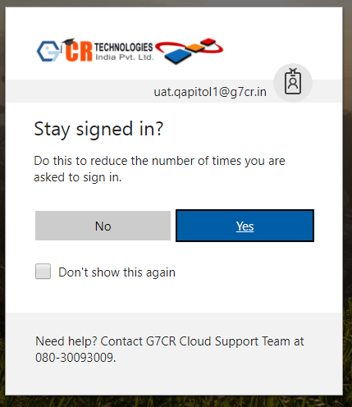

* User will login and land on the homepage of the web-app.

# Home Page

* On the home page a summarized detail of the user’s products is available as shown below.



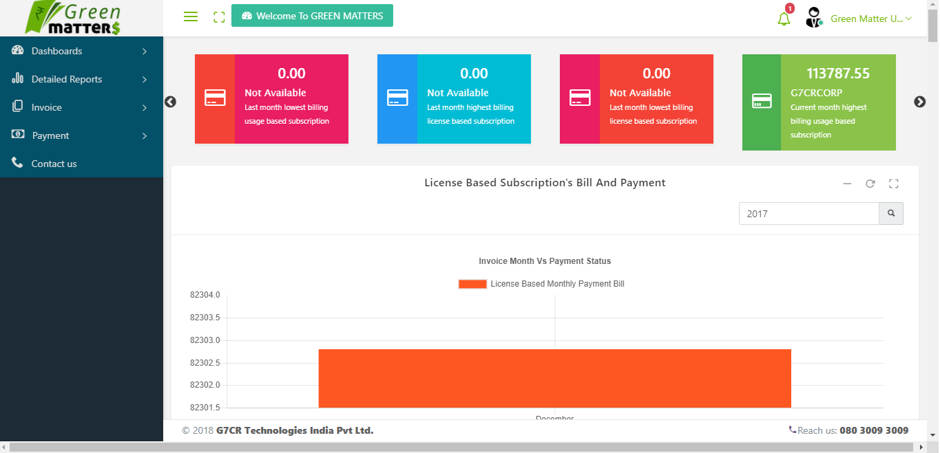





1. **Logo:** is a clickable function which allows the user to come back to the home page.
2. **Menu bar:** here the menu bar can be minimized and maximized as shown below:

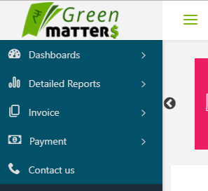**Minimized 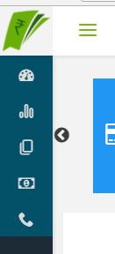 Maximized**

1. **Minimized and maximized:** Were the user can view the home page on full screen.
2. **Welcome to GREENMATTERS:** is a clickable function which allows the user to come back to the home page.
3. **Sliding bar:** Here summarized details are shown in a sliding format.
4. **Notification Bell:** Here all the notification of the customer is shown.
5. **Logout menu:** By clicking on the man like icon a dropdown opens to log out.

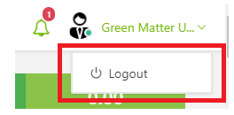

1. **Graph:**  Here the details are summarized in a graphical form for the customer usage based and licensed based.
2. **Useful tools:** Here the user can collapse the box, refresh the data and can view in full screen as well.
3. **Calendar:** User can select the desired month and year accordingly to view his data.
4. **Credit limit details:** Here the user can view his total and remaining credit limit details.

# Dashboard

Here the user can have a detailed view of their license and usage based data.

|  |  |  |
| --- | --- | --- |
| Types | License Based | Usage Based |
| Actual Bill Reports | **The bill against which the payment is to be made by the customer** | |
|  | Actual bill information is provided with is a license based report which is viewable only. They are in yearly, monthly and daily formats | Actual bill information is provided which is based on usage. They are in yearly, monthly and daily formats |
| Estimated Bill Reports | **Based on the average consumption and licensing holding an estimate figure is provided to the customer under this section** | |
|  | Here only current month information is provided which is just an estimated figure not actual bill amount. They are Up to date information of current cycle and the per day count of the license | Here only current month information is provided based on the usage. They are in daily usage, up to date in the current cycle with specific products. |
| Payment Reports | **Reports related to the payments made by the customer for that month can be viewed under this section** | |
|  | Here will provide the information of the outstanding amount for the current month were green stands for paid, yellow only partial payment made and red payment still due for the month. | It’s the same as license based payment reports. |

The view of the data for Licensed based and usage based will be as below:

**License Based:**

Click on “Dashboard” “Licensed Based” “Actual Bill Reports “or “Estimated Bill Reports “or “Payment Reports”

1. **Payment Monthly Bill (Actual License)**

Under this box/section the complete Monthly payment bill summary data for the user is shown via graphical representation and has the below buttons to help the user view the data as per his choice:

* Bar graph
* Calendar to select the desired year with the search button beside it
* Expand and Collapse
* Refresh
* Maximise and minimise
* Close

Hence the user can select any of the above-mentioned buttons and view the data.

1. **Data Box**

This is the box linked and shown right next to the License Status box. Here all the detailed description is provided for the user as per his requirement with product description, Quantity and the date with headings as below:

* Active License Subscription
* Suspended License Subscription
* Deleted License Subscription

As per the availability of the data as per that user and has a minimize and maximize button on the right Conner of the box to get a better view of the data.

1. **Total License Bill**

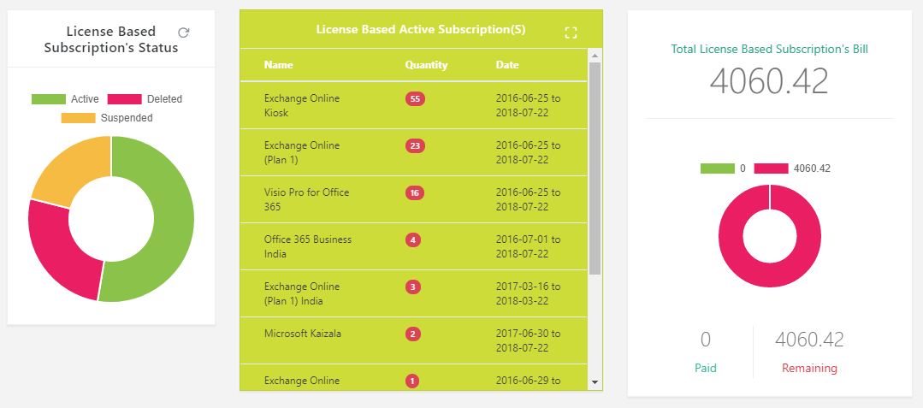This is just a box representing the data for better understanding for the user as to how many paid bills till date and Remaining bill.

1. **Yearly Actual Count Summary (License Base/ Actual Bill Report)**

Under this box/section the complete yearly data for the user is shown via graphical representation and has the below buttons to help him view the data as per his choice:

* Previous and Next
* Bar graph
* Pie chart
* Ascending/descending
* Calendar to select the desired year with the search button beside it
* Expand and Collapse
* Refresh
* Maximise and minimise

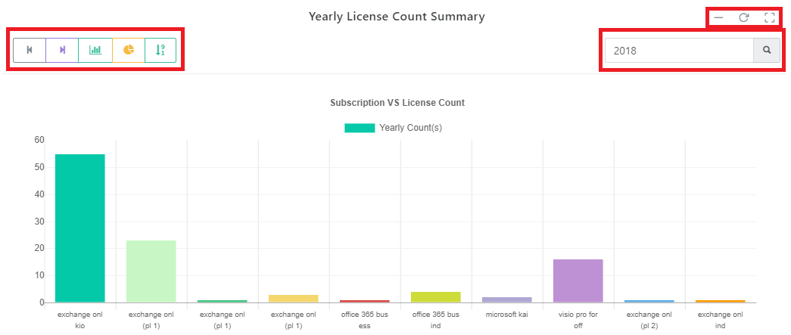Hence the user can select any of the above-mentioned buttons and view the data.

1. **Yearly Subscription Summary Bill (Actual License/ Actual Bill Report)**

Under this box/section the complete yearly data for the user is shown via graphical representation and has the below buttons to help him view the data as per his choice:

* Previous and Next
* Bar graph
* Pie chart
* Ascending/descending
* Calendar to select the desired year with the search button beside it
* Expand and Collapse
* Refresh
* Maximise and minimise

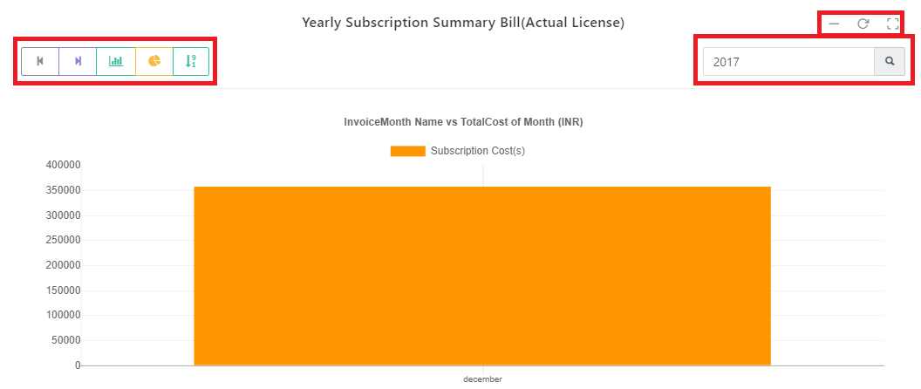Hence the user can select any of the above-mentioned buttons and view the data.

1. **Monthly Report Subscription Bill (Actual License/Actual Bill Report)**

Under this box/section the complete Monthly data for the user is shown via graphical representation and has the below buttons to help him view the data as per his choice:

* Previous and Next
* Bar graph
* Pie chart
* Ascending/descending
* Calendar to select the desired year with the search button beside it
* Expand and Collapse
* Refresh
* Maximise and minimise

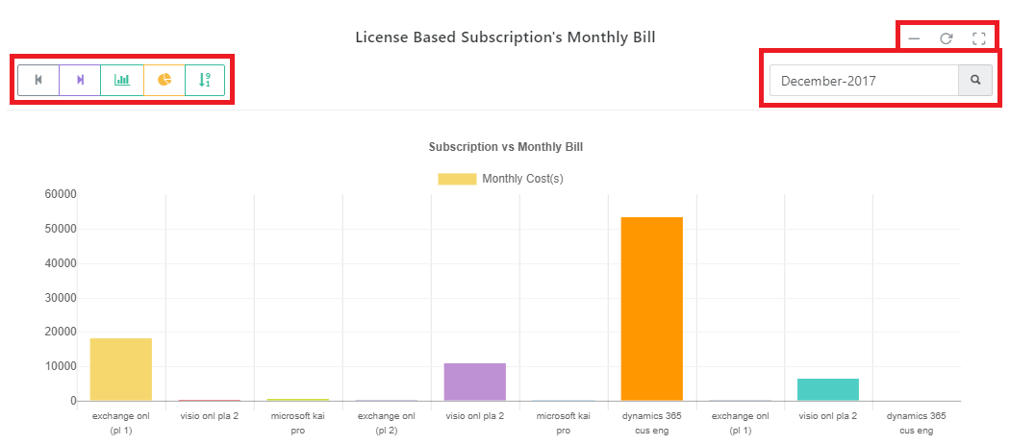Hence the user can select any of the above-mentioned buttons and view the data.

1. **Per Day Count Summary (Estimated License/ Estimate Report)**

Under this box/section the complete per day data for the user is shown via graphical representation and has the below buttons to help him view the data as per his choice:

* Previous and Next
* Bar graph
* Pie chart
* Ascending/descending
* Calendar to select the desired year with the search button beside it
* Expand and Collapse
* Refresh
* Maximise and minimise

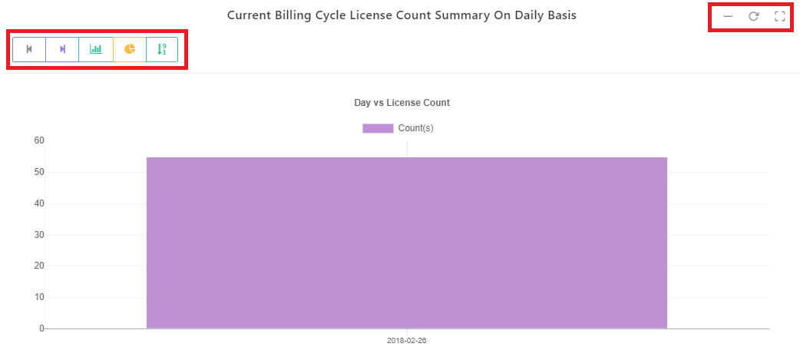Hence the user can select any of the above-mentioned buttons and view the data.

1. **Current Cycle Count Summary (Estimated License/Estimate Report)**

Under this box/section the complete Current cycle count summary data for the user is shown via graphical representation and has the below buttons to help him view the data as per his choice:

* Previous and Next
* Bar graph
* Pie chart
* Ascending/descending
* Calendar to select the desired year with the search button beside it
* Expand and Collapse
* Refresh
* Maximise and minimise

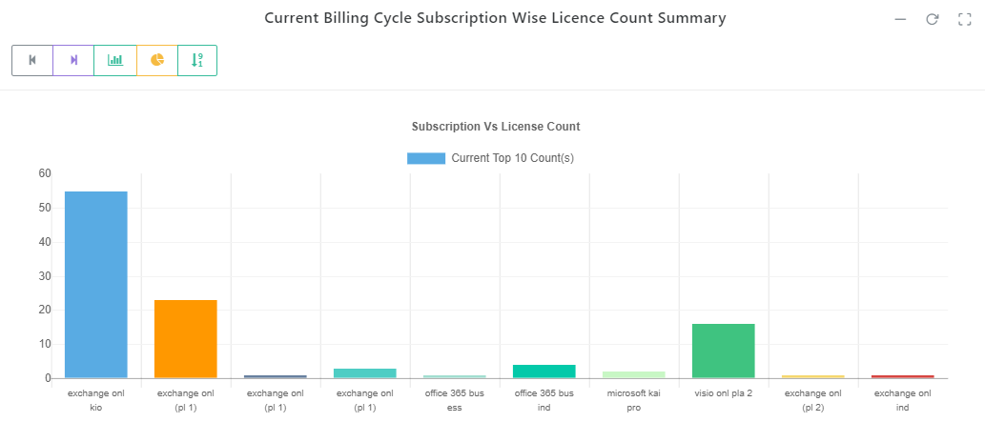Hence the user can select any of the above-mentioned buttons and view the data.

1. **Payment Monthly Bill (Usage Based/Payment Reports)**

Under this box/section the complete Monthly payment bill summary data for the user is shown via graphical representation and has the below buttons to help the user view the data as per his choice:

* Bar graph
* Calendar to select the desired year with the search button beside it
* Expand and Collapse
* Refresh
* Maximise and minimise
* Close

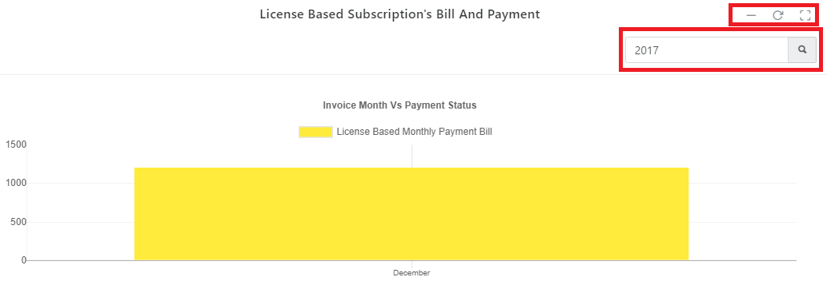Hence the user can select any of the above-mentioned buttons and view the data.

**Usage Based:**

Click on “Dashboard” “Usage Based” “Actual Bill Reports “or “Estimated Bill Reports “or “Payment Reports”

1. **Payment Monthly Bill (Usage Based)**

Under this box/section the complete Monthly payment bill summary data for the user is shown via graphical representation and has the below buttons to help the user view the data as per his choice:

* Bar graph
* Calendar to select the desired year with the search button beside it
* Expand and Collapse
* Refresh
* Maximise and minimise
* Close

Hence the user can select any of the above-mentioned buttons and view the data.

1. **Usage Status**

On the license status box, the details are summarised in a pie chart format representing 3 types of license data:

* Suspended
* Deleted
* Active

Refresh button on the right side of the box helps the user in refreshing the data to achieve the update/latest information.

And when the cursor in place on the pie chart accordingly with the colors against the data the number related to the data type appear on the screen. And when click at the same time the complete data appears on the box beside the License status box with the completed data information.

1. **Data Box**

This is the box linked and shown right next to the License Status box. Here all the detailed description is provided for the user as per his requirement with product description, and Creation date with headings as below:

* Active License Subscription
* Suspended License Subscription
* Deleted License Subscription

As per the availability of the data as per that user and has a minimize and maximize button on the right Conner of the box to get a better view of the data.

1. **Total Usage Bill**

This is just a box representing the data for better understanding for the user as to how many paid bills till date and Remaining bill.

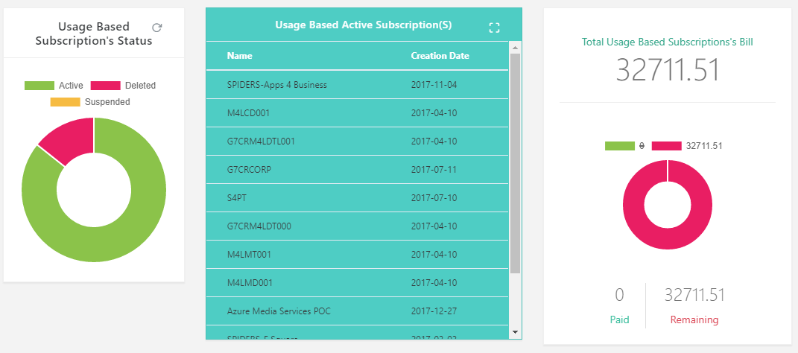

1. **Yearly Line Item Summary Bill (Actual Usage)**

Under this box/section the complete yearly data for the user is shown via graphical representation and has the below buttons to help him view the data as per his choice:

* Previous and Next
* Bar graph
* Pie chart
* Ascending/descending
* Calendar to select the desired year with the search button beside it
* Expand and Collapse
* Refresh
* Maximise and minimise
* Close

Hence the user can select any of the above-mentioned buttons and view the data.

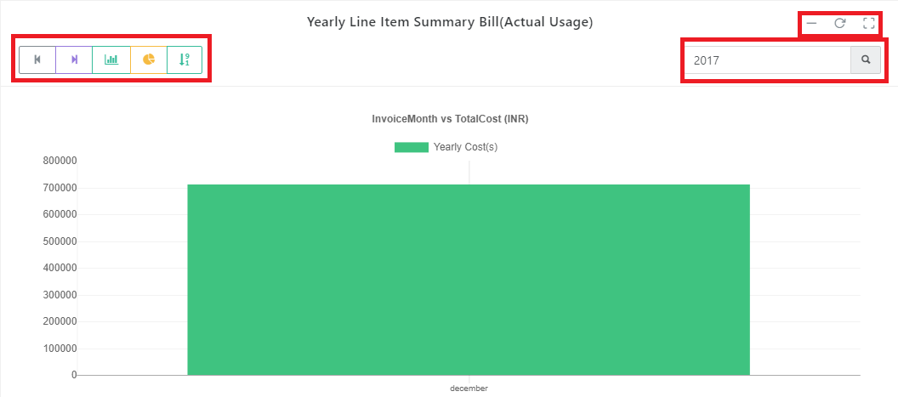

1. **Monthly Report Line item Bill (Actual Usage)** Under this box/section the complete monthly data for the user is shown via graphical representation and has the below buttons to help him view the data as per his choice:

* Previous and Next
* Bar graph
* Pie chart
* Ascending/descending
* Calendar to select the desired month & year with the search button beside it
* Expand and Collapse
* Refresh
* Maximise and minimise

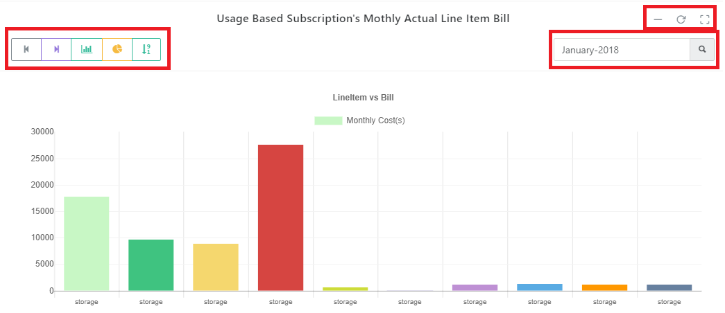Hence the user can select any of the above-mentioned buttons and view the data.

1. **Daily Line Item Summary Bill (Actual Usage)**

Under this box/section the complete Monthly data for the user is shown via graphical representation and has the below buttons to help him view the data as per his choice:

* Previous and Next
* Bar graph
* Pie chart
* Ascending/descending
* Calendar to select the desired month & year with the search button beside it
* Expand and Collapse
* Refresh
* Maximise and minimise

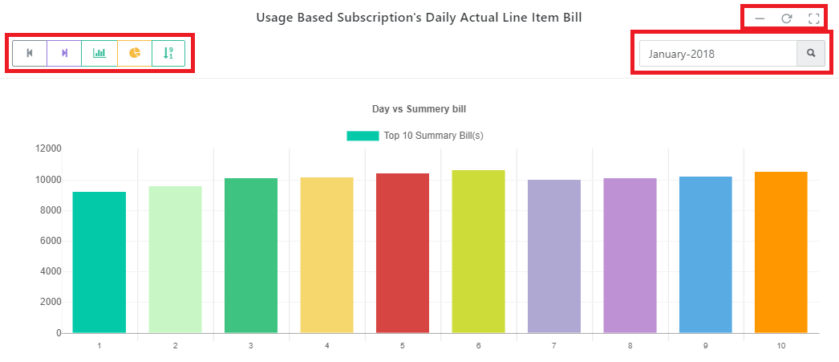Hence the user can select any of the above-mentioned buttons and view the data.

1. **Daily Line Item Bill (Estimated Usage)**

Under this box/section the complete Daily line item bill summary data for the user is shown via graphical representation and has the below buttons to help him view the data as per his choice:

* Previous and Next
* Bar graph
* Pie chart
* Ascending/descending
* Expand and Collapse
* Refresh
* Maximise and minimise

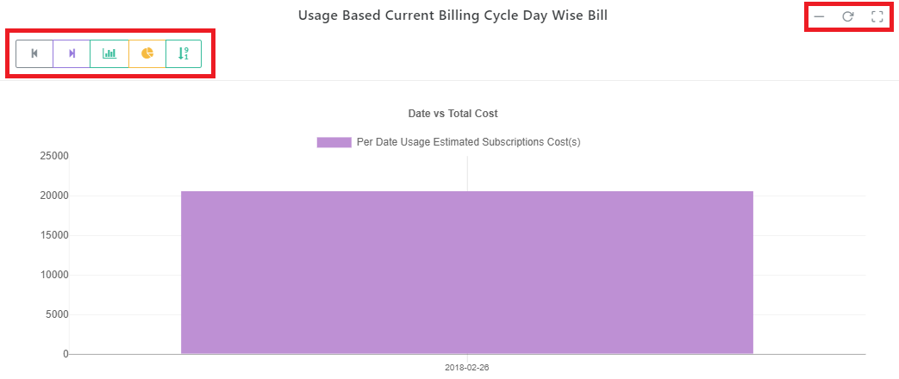Hence the user can select any of the above-mentioned buttons and view the data.

1. **Current Cycle Line Item Bill (Estimated Usage)**

Under this box/section the complete Current cycle bill summary data for the user is shown via graphical representation and has the below buttons to help him view the data as per his choice:

* Previous and Next
* Bar graph
* Pie chart
* Ascending/descending
* Expand and Collapse
* Refresh
* Maximise and minimise

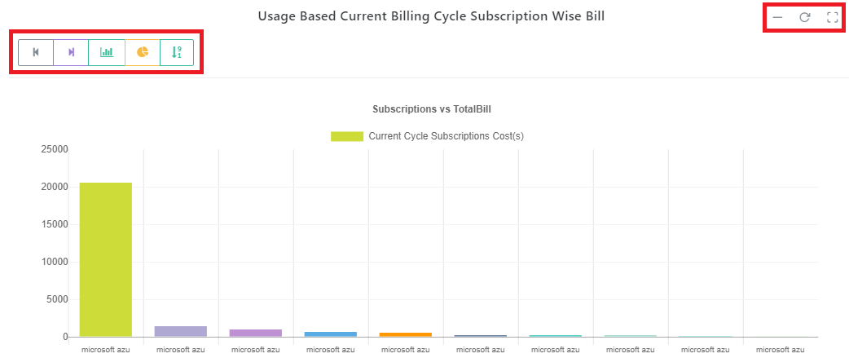Hence the user can select any of the above-mentioned buttons and view the data.

1. **Current Cycle Subscriptions Bill (Estimated Usage)**

Under this box/section the complete Current cycle subscription bill summary data for the user is shown via graphical representation and has the below buttons to help him view the data as per his choice:

* Previous and Next
* Bar graph
* Pie chart
* Ascending/descending
* Expand and Collapse
* Refresh
* Maximise and minimise

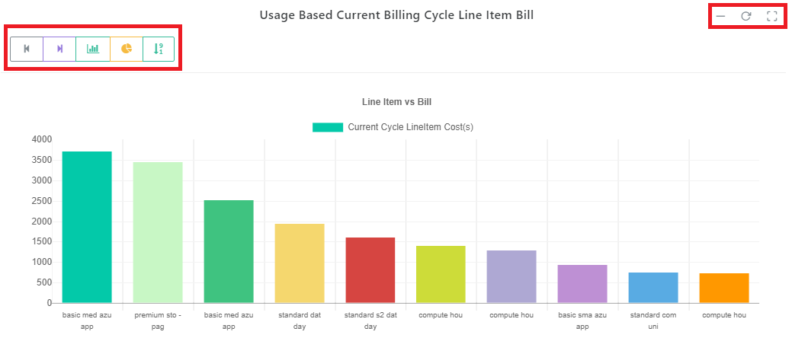Hence the user can select any of the above-mentioned buttons and view the data.

1. **Per Date Subscriptions Bill (Estimated Usage)**

Under this box/section the complete per day subscription bill summary data for the user is shown via graphical representation and has the below buttons to help him view the data as per his choice:

* Previous and Next
* Bar graph
* Pie chart
* Ascending/descending
* Expand and Collapse
* Refresh
* Maximise and minimise

Hence the user can select any of the above-mentioned buttons and view the data.

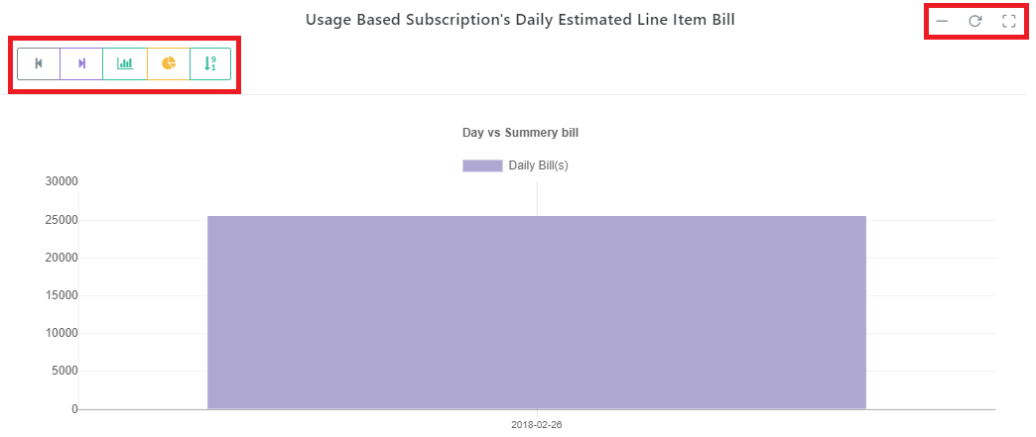

# Detailed Reports

**Here the user can not only view his data but also *can download the reports in an excel format. By clicking on download icon, the reports can be downloaded across all report types.***

**Reports are segregated based on the below types:**

* **Actual bill reports**

Click on “Detailed Reports” “Actual Bill Reports”

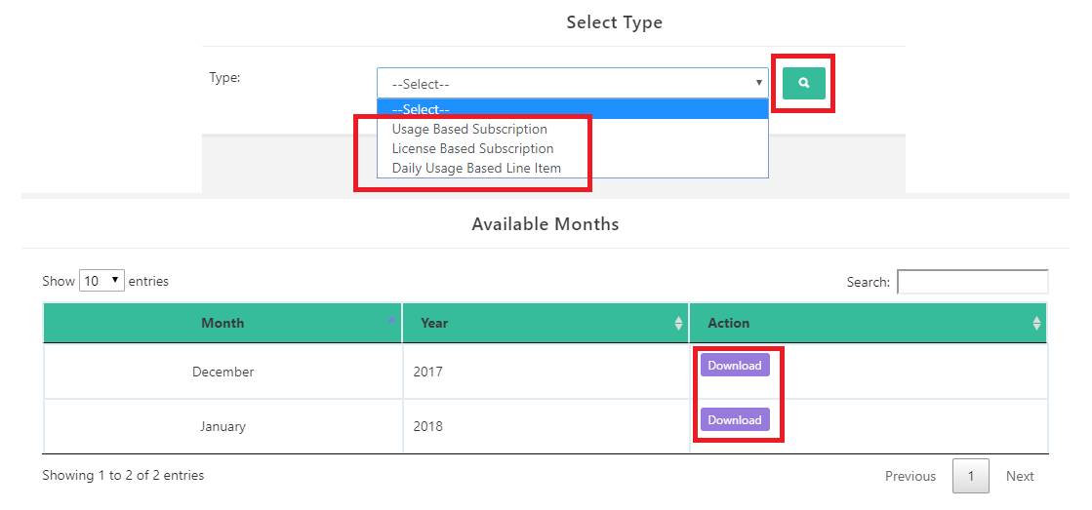

* Estimated bill reports
* Transaction reports
* Refund reports
* All subscriptions
* Promos Reports
* **Estimated bill reports**

Click on “Detailed Reports” “Estimated Bill Reports”

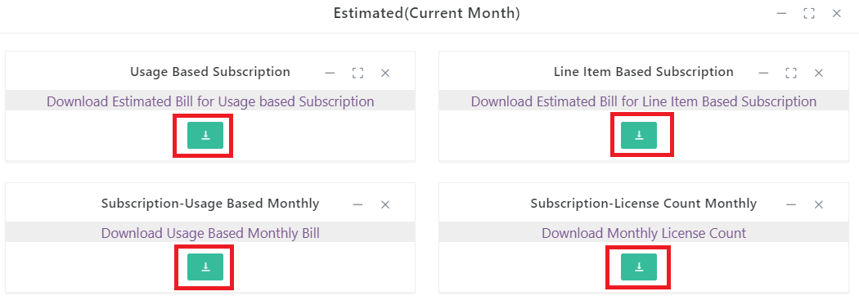

* **Transaction reports**

Click on “Detailed Reports” “Transaction Reports”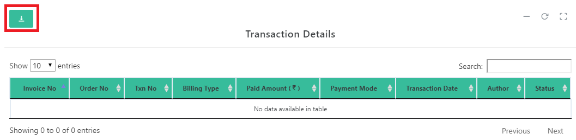

* **Refund reports**

Click on “Detailed Reports” “Refund Reports”

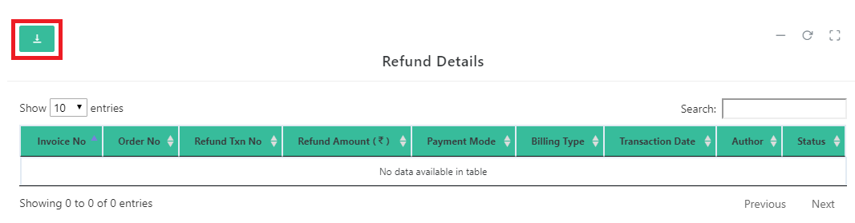

* **All subscriptions**

Click on “Detailed Reports” “All subscriptions”

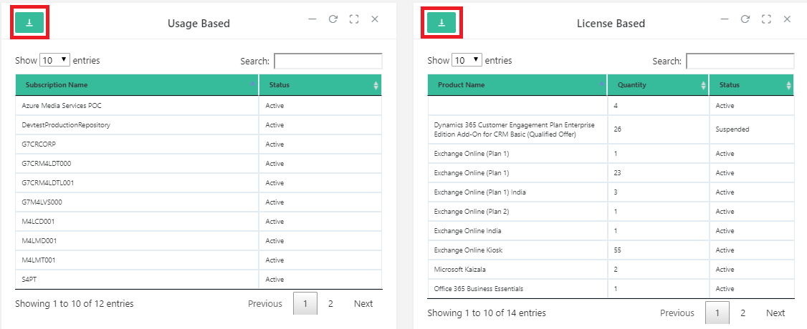

* **Promo Reports**

Click on “Detailed Reports” “Promo reports”

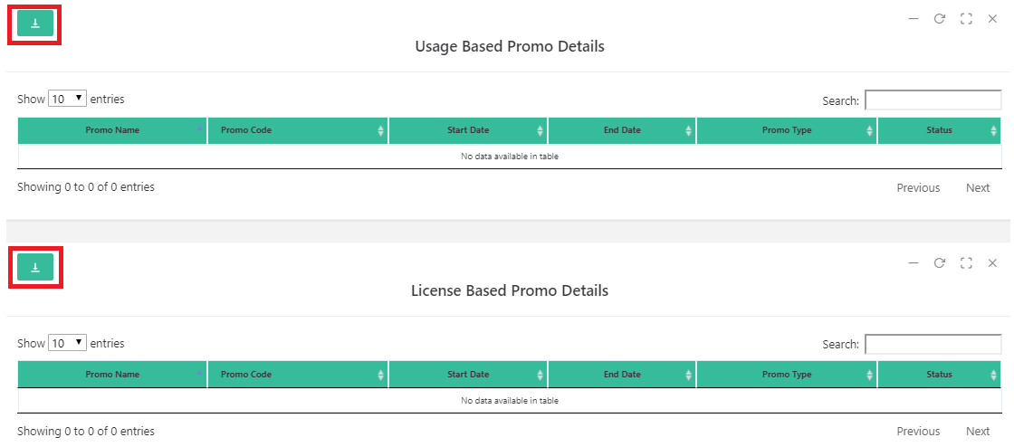

# Invoice

The user can view his past invoice and if required by the user they can even print invoices if required.

They are segregated into 2 types:

* Usage based Invoice
* License Based Invoice

**Usage Based:**

Click on “Invoice” “Usage based”. To just view the invoice just click on the desired invoice number and you will be able to view the invoice and to download just click on the download option and it will be saved in a PDF format.

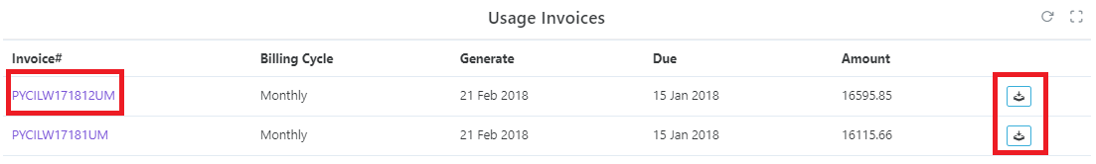

**License Based:**

Here it’s the same process as usage based the only difference is the data information.

# Payment

Click on “Payment” “Pending payment”. The user can make the payments for any due amount against the invoices and order numbers under this section.

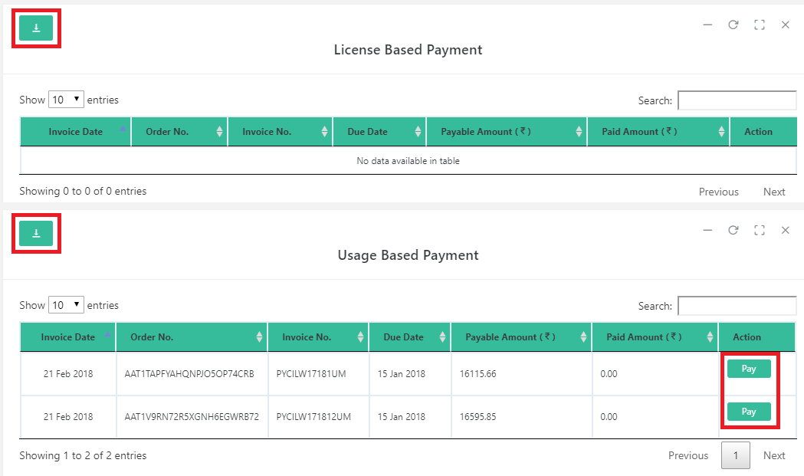

Once the user clicks on “Pay” payment section is displayed below with the related order number and amount payable. Here the user is given 2 types of payment modes: Online and Offline.

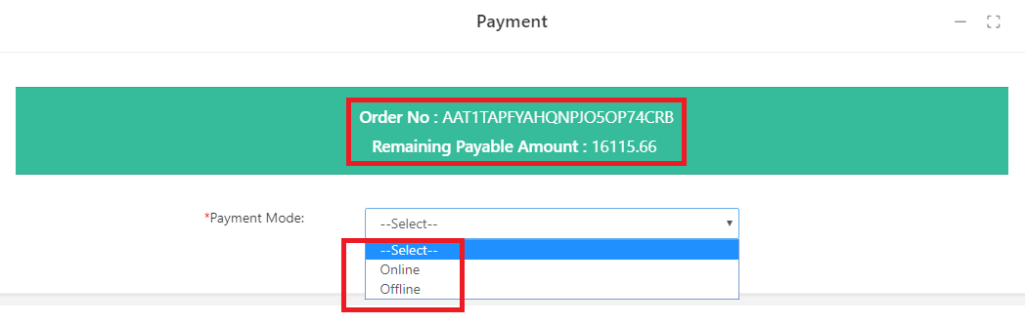

**Online payment:**

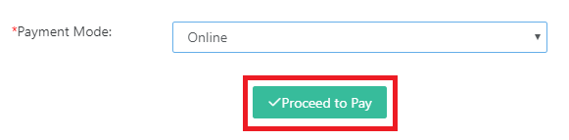

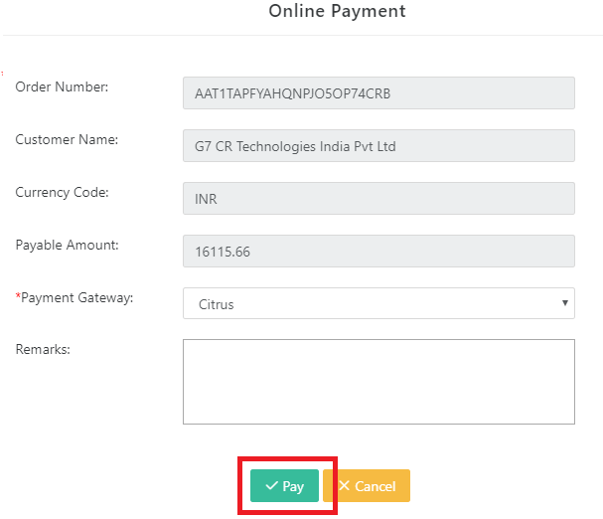

**Note:** the user will be redirected to the citrus payment gateway to complete the transaction.

**Offline Payment:**

Select the offline payment mode and complete all the mandatory fields and proceed to submit.

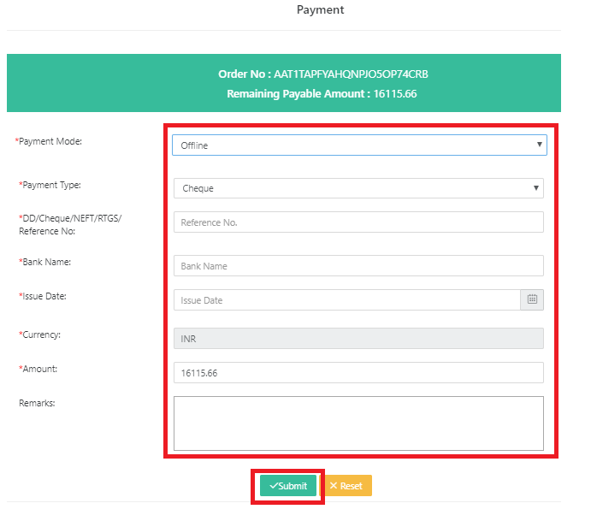

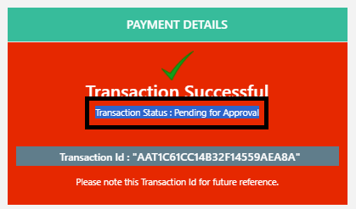

**Note:** the offline payments are sent for Approval.

# Contact Us

The user at any time has any issues, concerns or wants clarification and want to contact us, they can click on Contact us and complete the form and the relevant team will contact the customer.

**Form:**

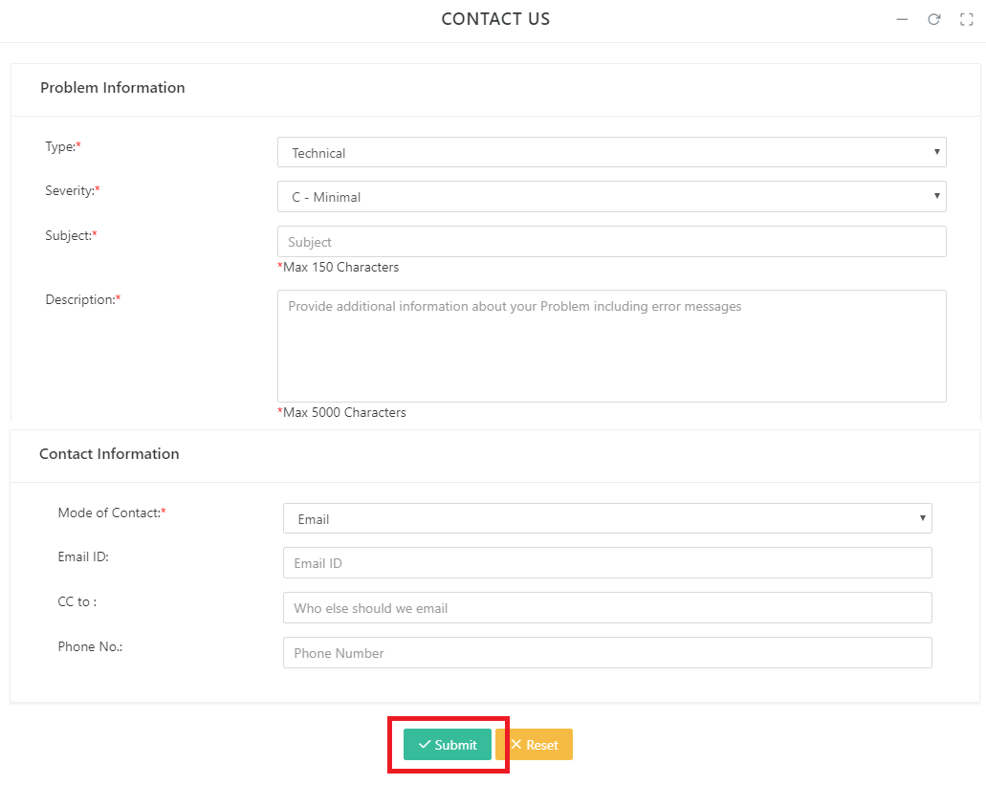

# 8. Mapping charges of an invoice

|  |  |  |  |
| --- | --- | --- | --- |
| **Invoice charges** | **Charge type** | **Charge description** | **Mapping Licensed based/ Usage based charges** |
| **Recurring Charges** | Activation fee | The amount charged to the customer when they use the subscription after purchasing it | From license-based file, sum the **Amount** column |
| Cancel fee | Prorated charges refunded to the customer when associated seats are changed |
| Cycle fee | Periodic charges for a subscription |
| Cycle instance prorate | Prorated charges assessed from the customer when associated seats are changed |
| Prorate fees when cancel | Prorated refund for unused portion of service upon cancellation |
| Prorate fees when purchase | Prorated fees upon purchase |
| Purchase fee | Initial charge for a subscription |
| Prorate fee when renew | Prorated fees upon subscription renewal |
| Renew fee | Charge for renewing a subscription |
| **Other Products and Services** | Prorate fees when activate | Prorated fees from activation until end of billing period | From license-based file, sum the **Amount** column |
| **Usage Charges** | Assess usage fee when cancel | Access usage fee upon cancellation for unpaid usage during the current billing period | From usage-based file, sum the **Pretax Charges** column |
| Assess usage fee for current cycle | Access usage fee for the current billing period |
| **Credits & Adjustments** | Offset a line item | Partial or whole refund to a line item, including taxes | From license-based file, sum the **Total for Customer** column  From usage-based file, sum the **Post Tax Total** column |
| **Other Discounts** (usage-based) | Activation discount | Discount applied when subscription activated | From usage-based file, sum the **Pretax Charges** column |
| Cycle discount | Discount applied on periodic charges |
| Renew discount | Discount applied when subscription renewed |
| Cancel discount | Charges applied when discounts cancelled |
| **Other Discounts** (license-based) | May be applied to multiple charge types |  | From license-based file, sum the **Total Other Discount** column |
| **Taxes** or **VAT** | May be applied to multiple charge types  Exception: "Offset a line item" already includes taxes. See Credits & Adjustments, above. | Taxes or value-added taxes (VAT) | From license-based file, sum the **Tax** column  From usage-based file, sum the **Tax Amount** column |

